**Service Description – Skill and job description proposal**

## Introduction

A proposal for the student to a job must be available. Otherwise we is not willing to continue interacting with the platform. If the students does not immediately can have an experience of success on the website with as little information as possible. He will most likely not coming back.

## Customer Segment

Students in their final year before graduation. They are thinking about on where to apply to and are not yet sure now.

## Functions

Matching the right people to the right jobs. The ML algorithm must be set up so far that he is able to extract the Skills from text / LinkedIn and match it to job descriptions (desired skills and properties).

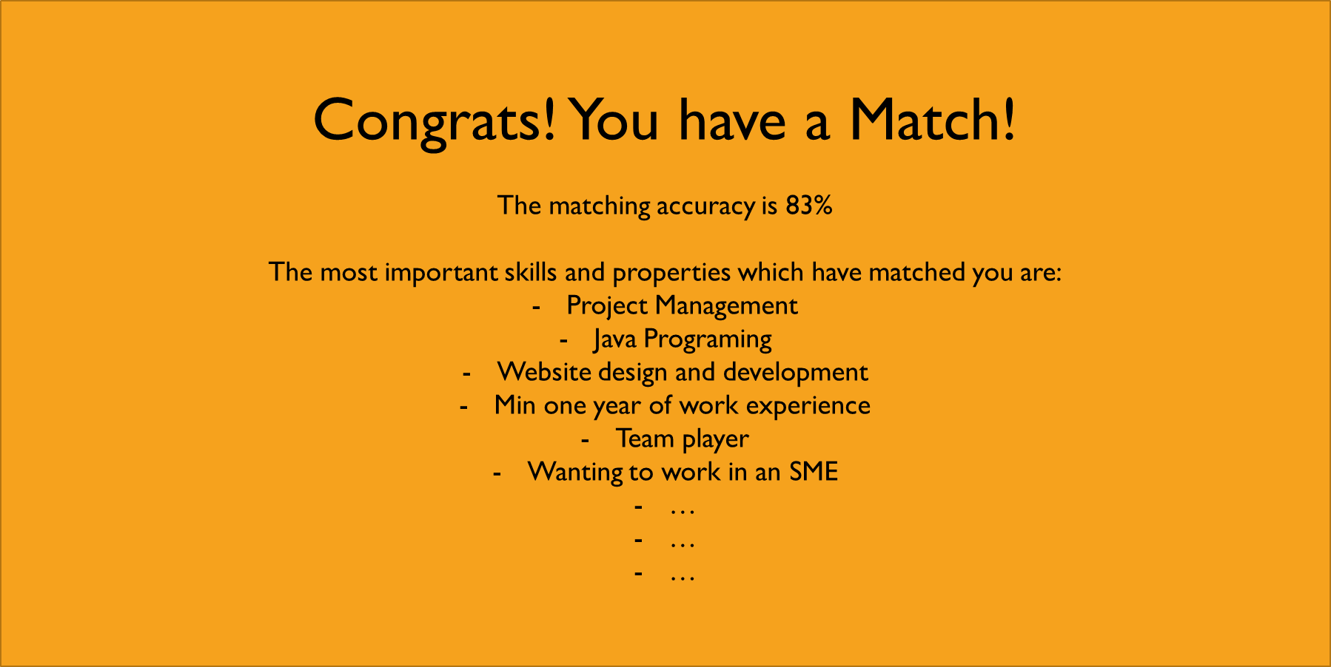

## Revenue Stream / ROI

Headhunter Fee.

## Value Proposition

The students find jobs which he would otherwise not had found if he just visited jobs.ch or monster. The search process is fast and convenient.

## Key Partners

Short-term – FHNW

LinkedIn? Do we need permission from them to access their data or just the permission form the user?

Long-term – All universities

Job platforms to cannibalize the jobs from.

## Actions required in order to realize the service

Find and set up a working text mining API.

Bewertung 1-6

|  |  |  |  |
| --- | --- | --- | --- |
|  | Peter | Yannick | Simon |
| Potential |  |  |  |
| Umsetzbarkeit |  |  |  |
| Priorität |  |  |  |
| MVP Relevanz |  |  |  |

Lean Canvas